**Step1**

Creating Resource Group

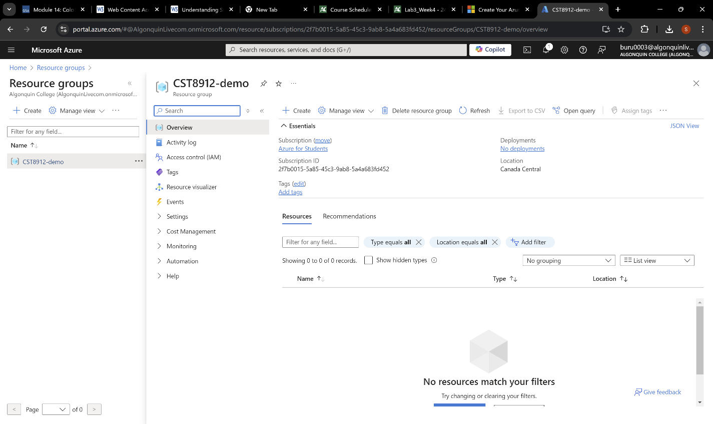

Creating Storage Account

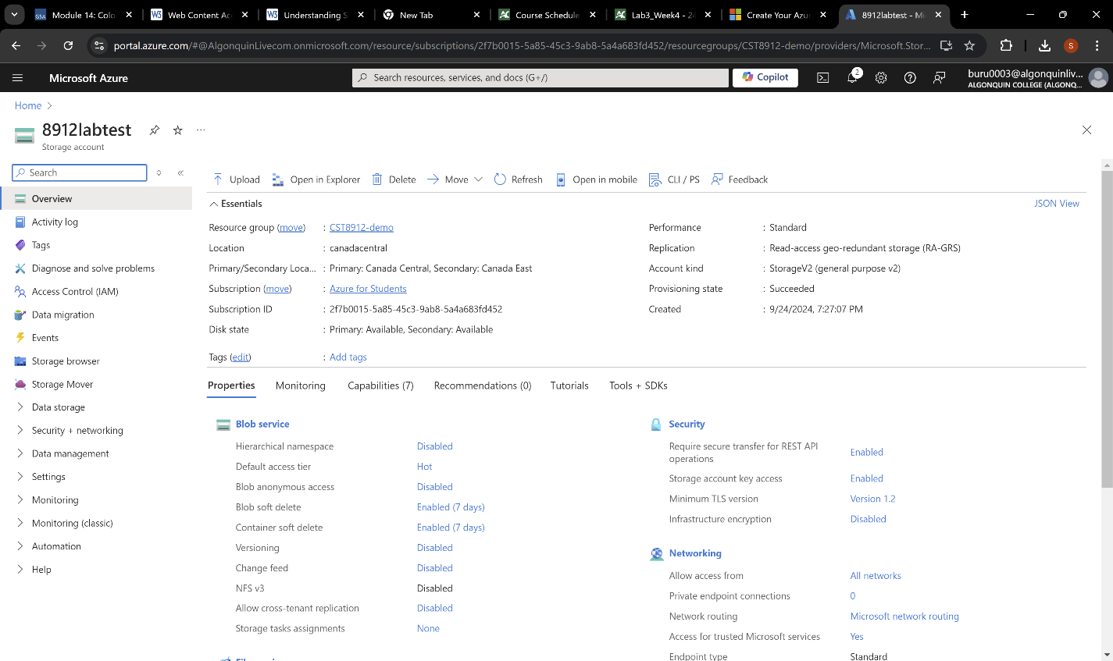

**Step2**

**Redundancy**

**Blob Access Tier**

**Step3**

**Creating Container**

**Creating folder and uploading sample file**

**Step4**

**Step5**

**Creating SAS**

**Downloading the sample file**

**Step6**

**Creating Rule**

**Step7**

**Deleting all resources**

